MIT World Peace University

Python Programming Mini Project Report

Neeraj Varma: 1032210651

Atharva Yadav: 1032210976

Yash Tekavade: 1032211025

**Introduction**

Inventory management is a crucial aspect of any business that deals with physical goods. Proper management of inventory can help a business optimize its operations, reduce costs, and maximize profits. In recent years, the use of technology has revolutionized inventory management by enabling businesses to automate and streamline their inventory processes. One such technology is the use of inventory management systems, which provide businesses with real-time visibility into their inventory levels, sales trends, and customer behaviour. This report aims to present an inventory management system written in Python and SQLite.

**Problem Statement**

Inefficient inventory management can be a major problem for businesses that deal with physical goods. Without proper inventory management, businesses may experience stockouts, overstocking, and other inventory-related issues that can lead to decreased sales, increased costs, and lower profits. Traditional inventory management methods, such as manual tracking and spreadsheets, can be time-consuming, error-prone, and lack real-time visibility. To address these challenges, businesses need a modern inventory management system that is efficient, scalable, and easy to use. Such a system must be able to track inventory levels in real-time, automate order processing, and provide accurate reporting to help businesses make informed decisions.

**Tasks Performed**

* Creation of user list
* Tracking of items taken per user
* Checkout GUI that lets the user select the items that they want to take

**Libraries Used**

* SQLite
* Tkinter
* OS

**Application Screenshots**

* User creation screen

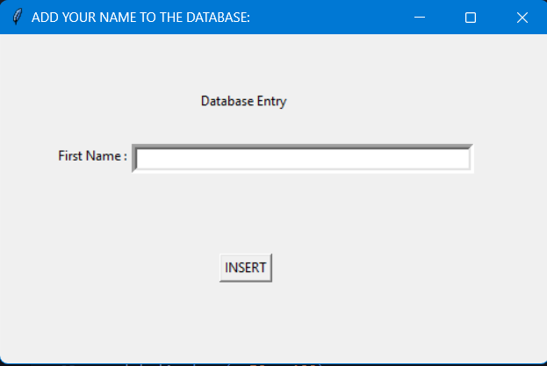

* Adding User database 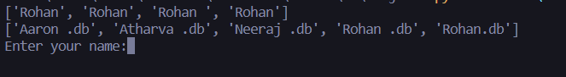
* Checkout GUI

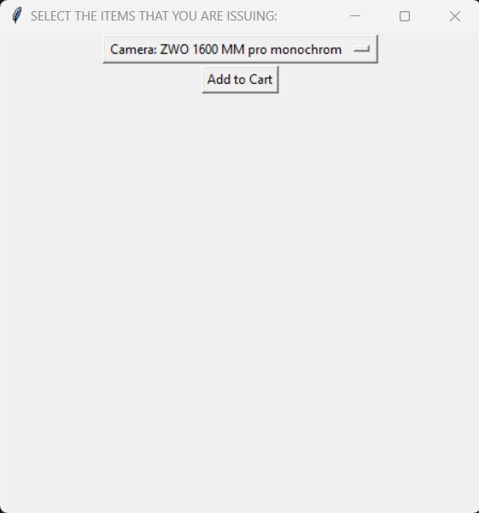

* Updated Table

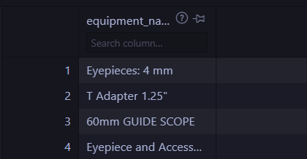

* User table



**Conclusion**

In conclusion, the inventory management system presented in this report provides a cost-effective and customizable solution for businesses looking to optimize their inventory management processes. By using Python and SQLite, the system is efficient, scalable, and easy to use, while also providing real-time visibility into inventory levels, sales trends, and customer behaviour